**Selenium Questions**

**What is software testing?**

**Types of testing?**

**What are levels of testing ?**

**Types of testing ?**

**What is selenium ?**

**What is selenium ?**

**Web driver is an interface.**

**Advantages and disadvantages of selenium web driver. – support ,os, programming language, multiple browse**

**Disadvantages;**

**There are two methods to get navigate**

**What is difference in close (); and quit(); method.**

**What is web element ???**

**What is DOM?**

**WHAT IS css ??**

**What is locator ??**

**Why we do need locators in selenium???????????**

**How many locators are there ??**

**Name the locators**

**What is attribute and what is values**

**Why there are so many locators ?? because some locators have duplicate values like id=”txt” and for other element id=”txt”**

**Three reasons**

**1. duplicate values**

**2. developers can t provide all locators for single element**

**3. link text is not applicable for button or other text box .**

**Some of the locator are not applicable to all the elements, like links.**

**---------------------------------------------------------------------------------------------------------------------------------------------------------------------------------------------------------------------------------------------------------------------------------------------------------------------------------------------------------------------------------------**

**Class 3**

**What is x path??**

**What is x and css selector path???**

**What are the types of x path???**

**Absolute x path? It always start with single slash and from very first tags <html>**

**Relative x path? It starts from any tags and double slash use**

**Advanced x path ??? in advanced x path we use parent, ancestors, siblings , child keywords.**

**//input[text()=’hello’] ---- text is not an attribute that s why @ not used here.**

**Contains method //input[contains(@class , 'inputtext')]**

**Starts-with method //input[starts-with(@class,'inputtext')]**

**//input[@id='calFromDate']/following-sibling::img**

**Why we need advanced x path??**

**When we can-not locate element by relative x path , then we need advanced x path**

**--preceding-sibling::tagename**

**--following-sibling::tagname**

**--/parent::tagname**

**/child::tagname**

**/ancestor::tagname**

**----------------------------------------------------------------------------------------------------------------------------------------------------------------------------------------------------------------------------------------------------------**

**SELENIUM CLASS 04**

**What is css selector (cascading styling sheet)**

**In css class attribute is represented by dot . input.text**

**In css class id locator is represented by # sign input#text**

**This is element example <label class="_58mt" for="u_4_4_3B">Female</label>**

**CSS syntax for class; label._58mt 🡨---- here dot (. ) mean class attribute**

**CSS syntax for ID.**

**Tagname#IDvalue**

**button#loginbutton 🡨------ here # sign mean ID locator.**

**this is contains method in CSS**

**input[type *='text']**

**CSS this is starts -with method in css.**

**input[attribute ^='starting attribute value']**

**CSS ends-with method**

**input[attribute $='ending attribute value']**

**img[src$=svg]**

**disadvantages of css selector ??**

**1. don not have text method as in x path**

**2. we can not go forward and backword as in x path siblings, parent**

**3.we can not use those values which have space, because css has no “” quots.s**

**4.don’t use large values only attribute with small values.**

**What is web element commands ?? the commands which show the state of web element on web page.**

**isEnabled**

**isDisabled**

**isSelected.**

**Is diplayed**

**What is mean by state of element? is physical condition/property of any button, checkbox, link, radio button.**

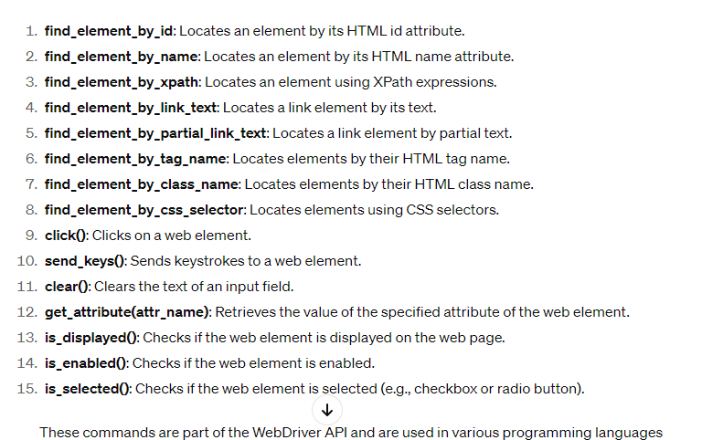

**Get text method**

**Get attribute methods**

**Is empty method**

**---------------------------------------------------------------------------------------------------------------------------------------------------------------------------------------------------------------------------------------------------------------------------------------------------------------------------------------------------------------------------------------**

**Selenium class 05**

1. **Radio Button**: A GUI element that Allows selecting only one option from a list, deselecting others automatically. Represented by small circles.
2. **Checkbox:** A GUI element that Allows selecting multiple options independently from a list. Represented by small square boxes.
3. **Dropdown:** A GUI element that Displays a menu of options from which one can be selected. Users click to reveal available choices and select one from the list

**Types of dropdown?**

**1.single select**

**2.multiple select**

**If you will use select class then you do not need to click method.**

**What is select class in selenium??**

In Selenium, the Select class is used to interact with dropdown menus or select elements on a web page. Dropdown menus in HTML are represented by <select> tags.

**The Select class provides methods to**

1. select options,
2. deselect options,
3. get all options, get the selected option, etc.

**How to handle drop down?**

**1. Select class use , there should be select tag in html.**

**There are three ways** to select an option from dropdown

1. By index
2. By visible text -- this is preferred way to select
3. By value --- value of attribute

**There are four deselect methods for deselect method drop down should be multiple select drop down**

1. Deselect by index

2. Deselect by visible text

3. Deselect by value

4. Deselect all

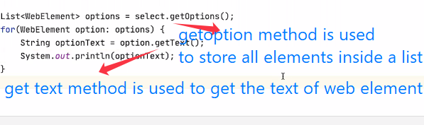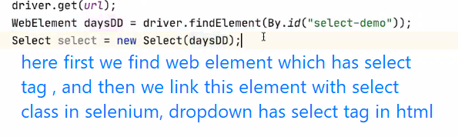

This is method to check drop down is multi select or not

Select select=new Select(element);  
boolean multiple=select.isMultiple();

--------------------------------------------------------------------------------------------------------------------------------------------------------------------------------------------------------------------------------------------------------------------------------------------------------------------------------------------------------------------------------------------------------------------------------------------------------

Selenium class 06

**What is alert???** Alert is pop up message that takes complete focus of main page.

You can-not proceed before handling

--------------------------------------------------------

Alert is a class in selenium which is used to switch selenium web driver to get access of Alert which are written in java script language

--------------------------------------------------------------

Selenium lose its access when an alert is pop up because selenium has only its access on webpage/web applications, but pop up alert is outside of webpage so to interact this we use alert class.

--------------------------------------------------

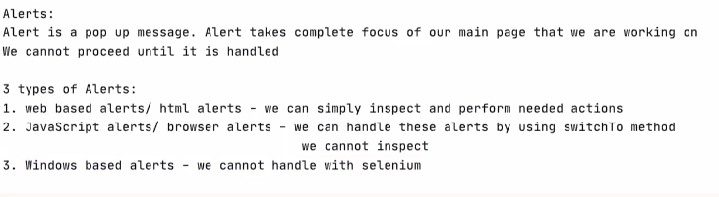

**Java script has three types alert;**

**Simple Alert:** This type of alert only contains a message and an OK button to close the alert.

**Confirmation Alert:** This type of alert contains a message, along with OK and Cancel buttons. It allows the user to confirm or cancel an action.

**Prompt Alert (amaada krna);** This type of alert also contains a message, along with text box where the user can enter some text OK and Cancel buttons as well.

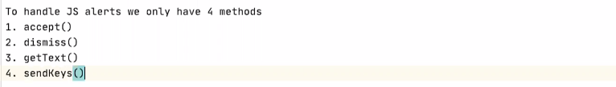

**What is difference in get text method of select class and alert class**

in dropdown it is used to get text of elements.

In alert it is used to get text from alert

**What is basic authentic alert pop up how to deal?**

**Just add credentials inside the url this is answer. //https:/username:password@basicp**

**--------------------------------------------------------------------------------------------------------------------------------------------------------------------------------------------------------------------------------------------------------------------------------------------------------------------------------------------------------------------------------------**

**What is inline frame?? Is separate independent html document (the document which is used to structure the web sites.) , Used to divide the web page into multiple sections. Each section is separate independent html document. Main page is one web page in which many frames/html documents embedded.**

**Why we need frames?? Client demand.**

**What are methods of frames?? Three- By id or name , by web element , by index**

**How you will handle alert in selenium?? Using alert interface.**

**How you will handle frames? By using switch to method.**

**----------------------------------------------------------------------------------------------------------------------------------------------------------------------------------------------------------------------------------------------------------**